**PROFESSIONAL TRAINING REPORT**

**at**

**Sathyabama Institute of Science and Technology (Deemed to be University)**

Submitted in partial fulfillment of the requirements for the award of Bachelor of Engineering Degree in Computer Science and Engineering

By

 **D. BHEEMASHANKARRAHUL**

**REG. NO. 39110286**

**DEPARTMENT OF COMPUTER SCIENCE AND ENGINEERING SCHOOL OF COMPUTING**

**SATHYABAMA INSTITUTE OF SCIENCE AND TECHNOLOGY**

**JEPPIAAR NAGAR, RAJIV GANDHI SALAI, CHENNAI – 600119, TAMILNADU**

**NOVEMBER 2021**

**DECLARATION**

I, **D. BHEEMASHANKARRAHUL** hereby declare that the project report entitled **AMAZON STORAGE SERVICES** done by me under the guidance of **DR. N. SRIDEVI ,M.E,phD** is submitted in partial fulfillment of the requirements for the award of Bachelor of Engineering Degree in Computer Science and Engineering.

**DATE:**

**PLACE: SIGNATURE OF THE CANDIDATE**

**ACKNOWLEDGEMENT**

I am pleased to acknowledge my sincere thanks to **Board of Management** of **SATHYABAMA** for their kind encouragement in doing this project and for completing it successfully. I am grateful to them.

I convey my thanks to **Dr. T. Sasikala M.E., Ph.D**, **Dean**, School of Computing, **Dr. S. Vigneshwari, M.E., Ph.D. and Dr. L. Lakshmanan, M.E., Ph.D., Heads of the Department** of **Computer Science and Engineering** for providing me necessary support and details at the right time during the progressive reviews.

I would like to express my sincere and deep sense of gratitude to my Project Guide **Dr. N. SRIDEVI, M.E., Ph.D.,** for her valuable guidance, suggestions and constant encouragement paved way for the successful completion of my project work.

I wish to express my thanks to all Teaching and Non-teaching staff members of the **Department of Computer Science and Engineering** who were helpful in many ways for the completion of the project.

**ABSTRACT**

Amazon Web Services (AWS) is a flexible, cost-effective, easy-to-use cloud computing platform. This whitepaper is designed to help architects and developers understand the different storage services and features available in the AWS Cloud. We provide an overview of each storage service or feature and describe usage patterns, performance, durability and availability, scalability and elasticity, security, interfaces, and the cost model.

Considering the expense and complexity of maintaining a traditional data center, it’s no wonder that companies are turning to cloud computing as a way to reduce costs, increase efficiencies, and build their business. With cloud computing, companies have access to a scalable platform; low-cost storage; database technologies; and management, deployment, and development tools on which to build enterprise-level solutions. Cloud computing helps businesses in the following ways: Reduces costs and complexity Adjusts capacity on demand Reduces time to market, Increases opportunities for innovation, Enhances security.

Amazon Web Services (AWS) gives customers access to cloud services at competitive prices, with the flexibility to meet their business needs. Whether it’s a small start up or a large enterprise, all companies can leverage the features and functionality of AWS to improve performance and increase productivity.

**LIST OF FIGURES**

|  |  |  |
| --- | --- | --- |
| **FIGURE NO.** | **FIGURE NAME** | **PAGE NO.** |
| 1.1 | Amazon Web Services Logo | 1 |
| 2.1 | Primary Storage Types in AWS | 2 |
| 2.2 | Amazon EBS | 3 |
| 2.3 | EC2 with EBS | 4 |
| 2.4 | EBS Snapshots Structure | 5 |
| 2.5 | Basic File Storage in AWS | 6 |
| 2.6 | Amazon EFS | 7 |
| 2.7 | Object Storage in AWS | 10 |
| 2.8 | Amazon S3 Standard | 12 |
| 2.9 | Amazon S3 Standard-IA | 13 |
| 2.10 | Amazon S3 Standard One-Zone IA | 13 |
| 2.11 | Amazon S3 Intelligent Tiering | 14 |
| 2.12 | Amazon Glacier | 15 |
| 2.13 | Amazon S3 Glacier Deep Archieve | 15 |

**LIST OF ABBREVIATIONS**

***ABBREVIATION EXPANSION***

AWS AMAZON WEB SERVICES

AMAZON EBS AMAZON ELASTIC BLOCK STORAGE AMAZON EFS AMAZON ELASTIC FILE SYSTEM

AMAZON S3 AMAZON SIMPLE STORAGE SERVICE S3 STANDARD IA S3 STANDARD INFREQUENT ACCESS

AMAZON RDS AMAZON RELATIONAL DATABASE SERVICES AWS DMS AWS DATABASE MIGRATION SERVICE AMAZON QLDB AMAZON QUANTUM LEDGER DATABASE AMAZON DAX AMAZON DYNAMODB ACCELERATOR

AMAZON EC2 AMAZON ELASTIC COMPUTE CLOUD

**TABLE OF CONTENTS**

|  |  |  |
| --- | --- | --- |
| CHAPTER NO. | TITLE  ABSTRACT | PAGE NO. |
| **1** | LIST OF FIGURES  LIST OF ABBREVIATIONS  **INTRODUCTION** | **1** |
|  | 1.1 WHAT IS CLOUD STORAGE? | 1 |
| **2** | **TYPES OF AWS STORAGE SERVICES** | **2** |
|  | 2.1 BLOCK STORAGE: AMAZON EBS | 2-6 |
|  | 2.2 FILE STORAGE | 6-9 |
|  | 2.3 OBJECT STORAGE: AMAZON S3 | 10-15 |
| **3** | **AMAZON DATABASE SERVICES** | **16** |
|  | 3.1 AMAZON RELATIONAL DATABASE SERVICES | 16-17 |
|  | 3.2 AMAZON NONRELATIONAL DATABASES | 17-18 |
|  | 3.3 AMAZON DYNAMODB | 18-19 |
|  | 3.4 AMAZON REDSHIFT | 19 |
|  | 3.5 AWS DATABASE MIGRATION SERVICES | 19 |
|  | 3.6 ADDITIONAL DATABASE SERVICES | 20 |
| **4** | **PRACTICAL EXPLANATION OF S3 BUCKETS** | **21** |
|  | 4.1 CREATION OF A S3 BUCKET | 21-23 |
|  | 4.2 ACCESSING A BUCKET | 23-24 |
|  | 4.3 DELETING A BUCKET | 25-26 |
| **5** | **PRACTICAL EXPLANATION OF AMAZON EBS** | **26** |

* 1. CREATION OF EBS SNAPSHOTS 26-28
  2. DELETION OF SNAPSHOTS 28

1. CONCLUSION 29
2. REFERENCES 30

**BUCKETS AND SNAPSHOTS**

**1. INTRODUCTION**

* 1. **WHAT IS CLOUD STORAGE?**

These cloud storage providers are responsible for keeping the data available and accessible, and the physical environment secured, protected, and running. Cloud Storage is a model of computer data storage in which the digital data is stored in logical pools, said to be on the cloud. The physical storage spans multiple servers(sometimes in multiple locations), and the physical environment is typically owned and managed by a hosting company. People and organizations buy or lease storage capacity from the providers to store user, organization, or application data.



Fig:1.1 Amazon Web Services logo

1. **TYPES OF AWS STORAGE SERVICES**

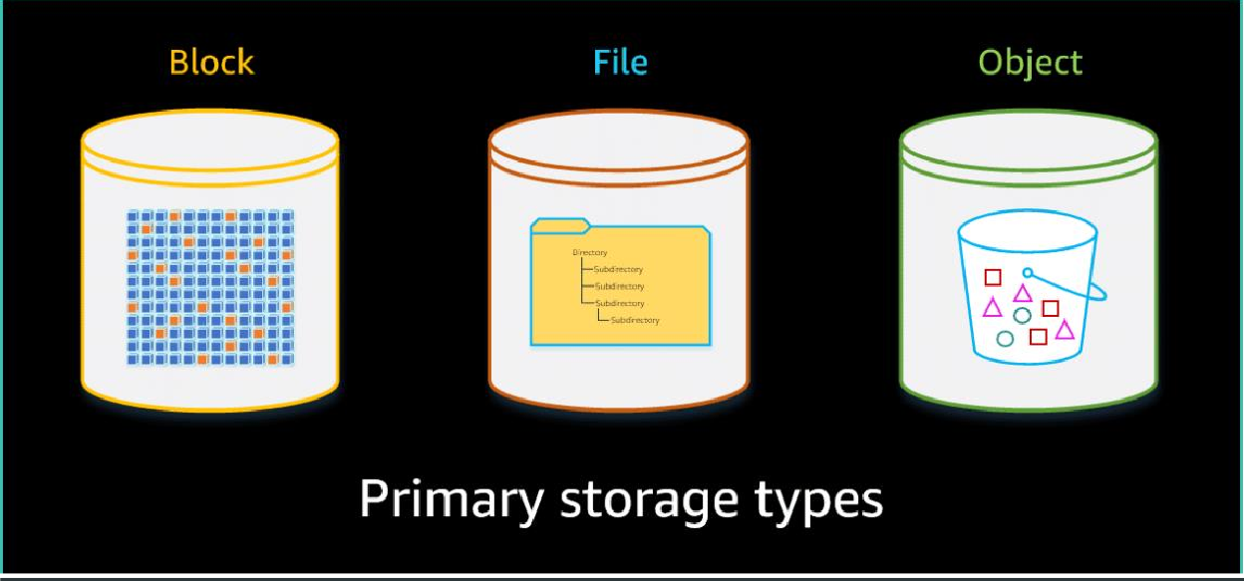

Fig:2.1 Primary Storage Types in AWS

* 1. **BLOCK STORAGE: AMAZON EBS**

The AWS block storage portfolio consists of two types of block storage services: **Amazon Elastic Compute Cloud (Amazon EC2)** instance storage and **Amazon Elastic Block Store (Amazon EBS)**. Amazon EBS also includes an integrated snapshot service. Amazon EBS is the primary block storage service.

C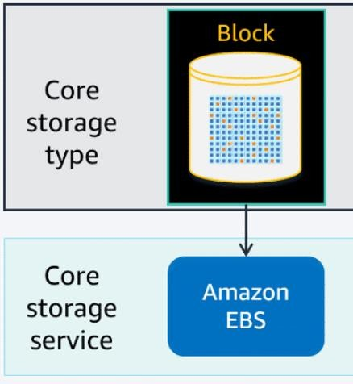

Fig:2.2 Amazon EBS

**Amazon EBS** is an easy-to-use, high performance, block storage service. It is designed for use with Amazon EC2 compute instances for both throughput and transaction-intensive workloads at any scale.

AWS recommends Amazon EBS for data that must be quickly accessible and requires long-term persistence. EBS volumes are well suited for use as the primary storage for file systems, databases, or any applications that require fine granular updates and access to raw, unformatted, block-level storage. Amazon EBS is well suited to both database-style applications that rely on random reads and writes and to throughput-intensive applications that perform long, sequential reads and writes.

EBS volumes behave like raw, unformatted block devices. You can mount these block devices as EBS volumes on your EC2 instances. EBS volumes that are attached to an EC2 instance are exposed as raw block storage volumes that persist independently from the life of the instance. You can create a file system on top of these volumes or use them in any way you would use a block device (such as a hard

drive). You can dynamically change the configuration of a volume attached to an EC2 instance, unlike traditional disk drives that come in fixed sizes.

You can choose from different EBS volume types to balance optimal price and performance. You can achieve single-digit millisecond latency for high-performance database workloads, such as SAP HANA, or gigabyte-per-second throughput for large, sequential workloads such as Apache Hadoop. You can change EBS volume types, tune performance, or increase volume size without disrupting your critical applications. Amazon EBS provides you cost-effective block storage when you need it.

Designed for mission-critical systems, EBS volumes are replicated within an AWS Availability Zone and can scale to store petabytes of data. Also, you can use EBS snapshots with automated lifecycle policies to back up your volumes in **Amazon Simple Storage Service (Amazon S3)**. You can do this while ensuring geographic protection of your data and business continuity.

With **Amazon EBS**, you pay only for the storage and resources that you provision.

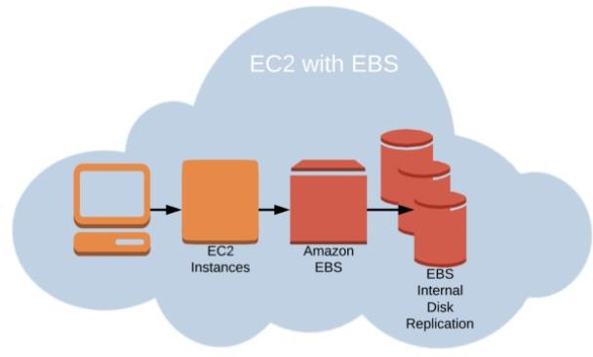

Fig:2.3 EC2 with EBS



***2.1.1 Amazon EBS snapshots***

The first EBS snapshot backs up all source data from the EBS volume. Additional snapshots add or remove data that has changed since the previous snapshot.

An EBS snapshot is an incremental backup. This means that the first backup taken of a volume copies all the data. For subsequent backups, only the blocks of data that have changed since the most recent snapshot are saved.

Incremental backups are different from full backups, in which all the data in a storage volume copies each time a backup occurs. The full backup includes data that has not changed since the most recent backup.

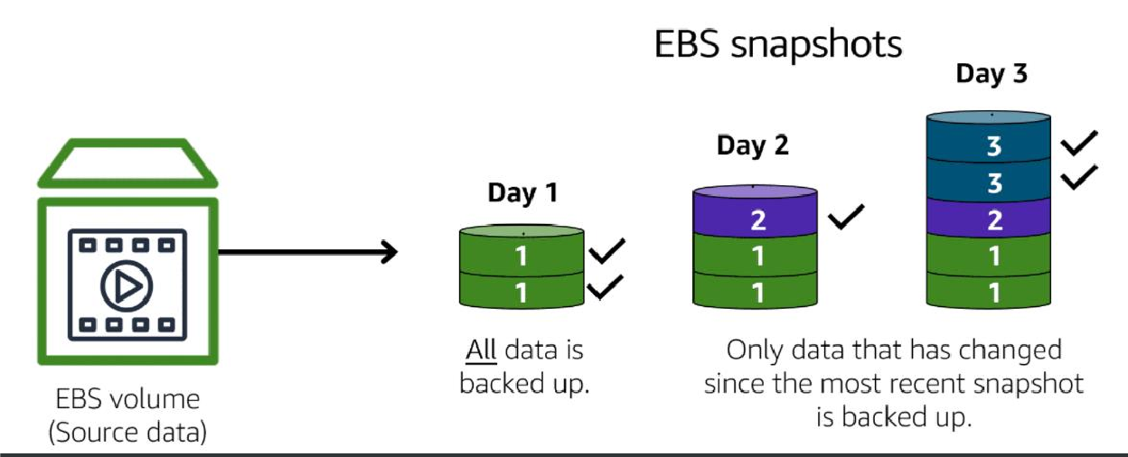

Fig:2.4 EBS snapshots structure

### 2.1.2 Pricing

With **Amazon EBS**, you pay only for what you use. Pricing for EBS volumes is based on the volume type, provisioned volume size, and the provisioned IOPS and throughput performance. EBS volume pricing varies based on the Availability Zone

where it resides. The pricing for **Amazon EBS snapshots** is based on the actual amount of storage space that you use.

* 1. **FILE STORAGE**

AWS currently offers three different managed file storage services to meet your application, workflow, and use-case requirements. In addition, you can use **Amazon EBS** to create self-managed file systems.

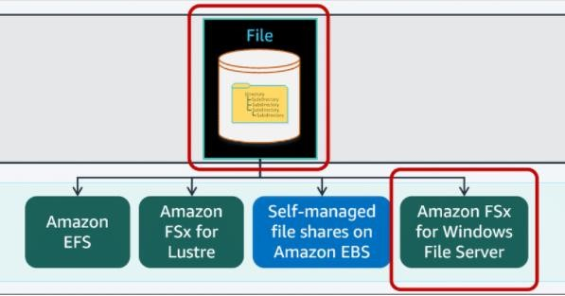

Fig:2.5 Basic File Storage in AWS

### Amazon EFS

**Amazon EFS** has a simple web services interface where you can create and configure file systems quickly and easily. The service manages all the file storage infrastructure for you, meaning that you can avoid the complexity of deploying, patching, and maintaining complex file system configurations. **Amazon EFS** file

systems can grow to petabyte scale, drive high levels of throughput, and allow massively parallel access from compute instances to your data.

**Amazon EFS** supports the Network File System version 4 (NFSv4.1 and NFSv4.0) protocol. The applications and tools that you use today work seamlessly with Amazon EFS. Multiple compute modules can access an Amazon EFS file system at the same time. These modules include Amazon EC2, AWS Lambda, Amazon Elastic Container Service (Amazon ECS), and Amazon Elastic Kubernetes Service (Amazon EKS).

Accessing compute services provides a common data source for workloads and applications running on more than one compute instance or container.

With **Amazon EFS**, you pay only for the storage used by your file system, with no minimum fee or setup cost. Amazon EFS offers a range of storage classes designed for different use cases. These include:

* + - * **Standard storage classes** – EFS Standard and EFS Standard–Infrequent Access (Standard–IA), which offer multiple Availability Zones (Multi-AZ) resilience and the highest levels of durability and availability.
      * **One Zone storage classes** – EFS One Zone and EFS One Zone–Infrequent Access (EFS One Zone–IA), which offer additional savings by choosing to save data in a single-Availability Zone (Single-AZ).



Fig:2.6 Amazon EFS

*2.2.1.1 Pricing*

With Amazon EFS, you pay only for the resources that you use. No minimum fee and no set-up charges are incurred. You pay only for the storage you use for read and write access to data stored in Infrequent Access storage classes and any provisioned throughput. Amazon EFS pricing varies based on the AWS Region where it resides and the storage class. Additional charges apply for Provisioned Throughput.

### Amazon FSx for Lustre

**FSx for Lustre** is a managed storage service developed on the open-source, high- performance Lustre file system.

The open-source Lustre file system is designed for compute-intensive applications that require a fast storage system capable of meeting throughput requirements. It is also designed to meet input/output operations per second (IOPS) requirements at scale. FSx for Lustre was built to process large datasets quickly and cost-effectively and scale to meet growing demands. **An FSx for Lustre** file system is capable of delivering hundreds of gibibytes (GiB) per second of throughput and millions of IOPS.

With **FSx for Lustre**, you can use the Lustre file system for any workload where speed matters. You do not have the traditional complexity of setting up and managing the Lustre storage system on premises. With **FSx for Lustre**, you can start your high- performance file system in minutes without the capital investment and operational management expense.

*2.2.2.1 Pricing*

The FSx for Lustre managed service offers predictable usage-based pricing. You pay only for the resources you use. No minimum fees are applied or no setup charges are

incurred. Costs are calculated by the number of seconds your file system is provisioned.

### Amazon FSx for Windows File Server

**Amazon FSx for Windows File Server** provides fully managed Microsoft Windows file servers, backed by a fully native Windows file system. **Amazon FSx for Windows File Server** has the features, performance, and compatibility to easily lift and shift enterprise applications to the AWS Cloud.

To access file storage over a network, FSx for Windows File Server provides native support for Windows file system features and for the SMB protocol. Amazon FSx is optimized for enterprise applications in AWS with native Windows compatibility, enterprise performance and features, and consistent sub millisecond latencies.

With file storage on FSx for Windows File Server, the code, applications, and tools that Windows developers and administrators use can continue to work unchanged. Windows applications and workloads ideal for FSx for Windows File Server include the following:

* + - * Business applications
      * Home directories
      * Web serving
      * Content management
      * Data analytics
      * Software build setups
      * Media processing workloads
  1. **OBJECT STORAGE: AMAZON S3**

In **object storage**, each object consists of data, metadata, and a key.

The data might be an image, video, text document, or any other type of file. Metadata contains information about what the data is, how it is used, the object size, and so on. An object’s key is its unique identifier.

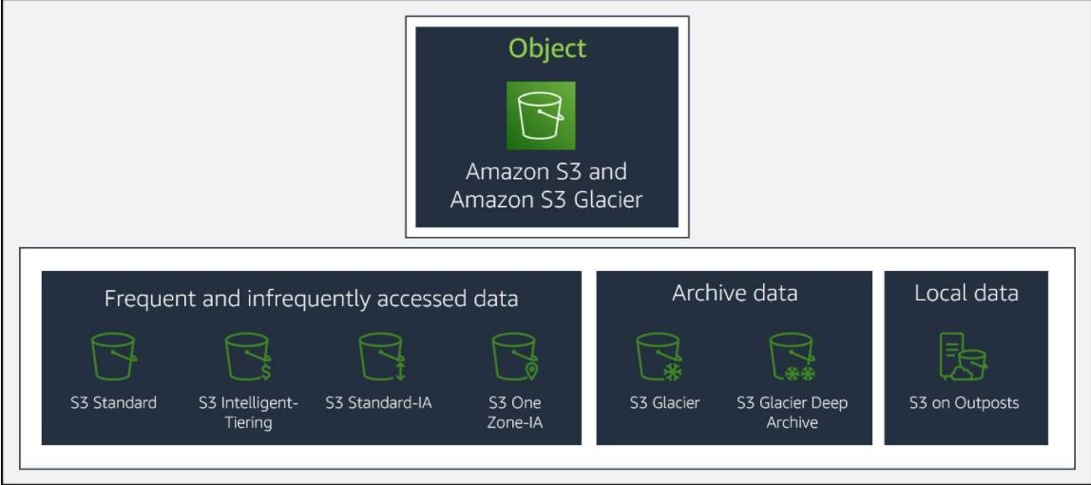

Fig:2.7 Object Storage in AWS

### Amazon Simple Storage Service (Amazon S3)

[*Amazon Simple Storage Service (Amazon S3)*](https://aws.amazon.com/s3/) is a service that provides object-level storage. Amazon S3 stores data as objects in buckets.

You can upload any type of file to Amazon S3, such as images, videos, text files, and so on. For example, you might use Amazon S3 to store backup files, media files for a website, or archived documents. Amazon S3 offers unlimited storage space. The maximum file size for an object in Amazon S3 is 5 TB.

When you upload a file to Amazon S3, you can set permissions to control visibility and access to it. You can also use the Amazon S3 versioning feature to track changes to your objects over time.

* + - 1. *Amazon S3 storage classes:*

With Amazon S3, you pay only for what you use. You can choose from [a range of](https://aws.amazon.com/s3/storage-classes) [storage classes](https://aws.amazon.com/s3/storage-classes) to select a fit for your business and cost needs. When selecting an Amazon S3 storage class, consider these two factors:

* + - * + How often you plan to retrieve your data
        + How available you need your data to be Learn more about the Amazon S3 storage classes:
      1. *S3 Standard:*
         * Designed for frequently accessed data
         * Stores data in a minimum of three Availability Zones
         * S3 Standard provides high availability for objects. This makes it a good choice for a wide range of use cases, such as website content distribution, and data

analytics. S3 Standard has a higher cost than other storage classes intended for infrequently accessed data and archival storage.

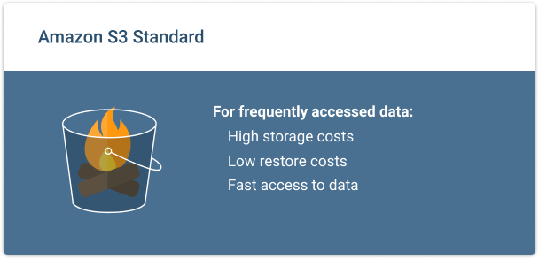

Fig:2.8 Amazon S3 Standard

* + - 1. *S3 Standard-Infrequent Access (S3 Standard-IA):*
         * Ideal for infrequently accessed data
         * Similar to S3 Standard but has a lower storage price and higher retrieval price

S3 Standard-IA is ideal for data infrequently accessed but requires high availability when needed. Both S3 Standard and S3 Standard-IA store data in a minimum of three Availability Zones. S3 Standard-IA provides the same level of availability as S3 Standard but with a lower storage price and a higher retrieval price.

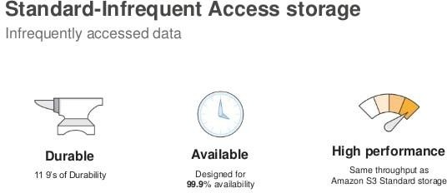

Fig:2.9 Amazon S3 Standard-IA

* + - 1. *S3 One Zone-Infrequent Access (S3 One Zone-IA):*
         * Stores data in a single Availability Zone
         * Has a lower storage price than S3 Standard-IA

Compared to S3 Standard and S3 Standard-IA, which store data in a minimum of three Availability Zones, S3 One Zone-IA stores data in a single Availability Zone. This makes it a good storage class to consider if the following conditions apply:

* + - * + You want to save costs on storage

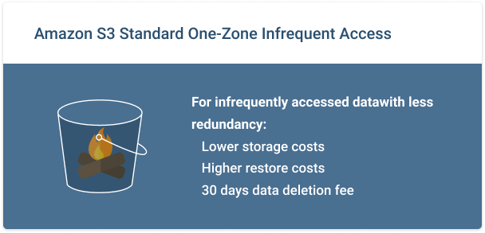

Fig:2.10 Amazon S3 Standard One-Zone IA

* + - 1. *S3 Intelligent-Tiering:*
         * Ideal for data with unknown or changing access patterns
         * Requires a small monthly monitoring and automation fee per object

In the S3 Intelligent-Tiering storage class, Amazon S3 monitors objects’ access patterns. If you haven’t accessed an object for 30 consecutive days, Amazon S3 automatically moves it to the infrequent access tier, S3 Standard-IA. If you access an object in the infrequent access tier, Amazon S3 automatically moves it to the frequent access tier, S3 Standard.

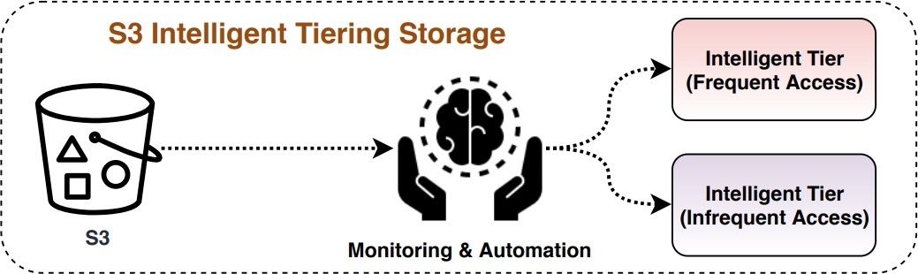

Fig:2.11 Amazon S3 Intelligent Tiering

* + - 1. *S3 Glacier:*
         * Low-cost storage designed for data archiving
         * Able to retrieve objects within a few minutes to hours

S3 Glacier is a low-cost storage class that is ideal for data archiving. For example, you might use this storage class to store archived customer records or older photos and video files.

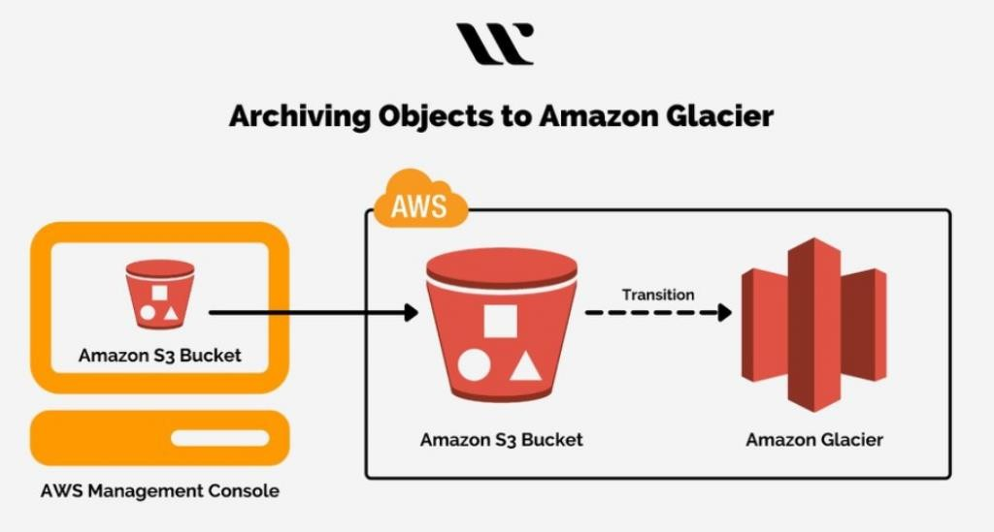

Fig:2.12 Amazon Glacier

* + - 1. *S3 Glacier Deep Archive:*
         * Lowest-cost object storage class ideal for archiving
         * Able to retrieve objects within 12 hours

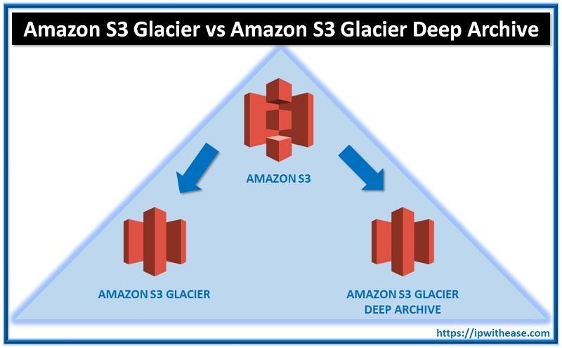When deciding between Amazon S3 Glacier and Amazon S3 Glacier Deep Archive, consider how quickly you need to retrieve archived objects. You can retrieve objects stored in the S3 Glacier storage class within a few minutes to a few hours. By comparison, you can retrieve objects stored in the S3 Glacier Deep Archive storage class within 12 hours.

Fig:2.13 Amazon S3 Glacier Deep Archieve

1. **AMAZON DATABASE SERVICES**

Amazon Database Services are divided into two types:

1. Amazon Relational Database Service. 2.Amazon Non-Relational Database Service.
   1. **AMAZON RELATIONAL DATABASE SERVICE (AMAZON RDS)**

In a **relational database**, data is stored in a way that relates it to other pieces of data.

Relational databases use **structured query language (SQL)** to store and query data. This approach allows data to be stored in an easily understandable, consistent, and scalable way.

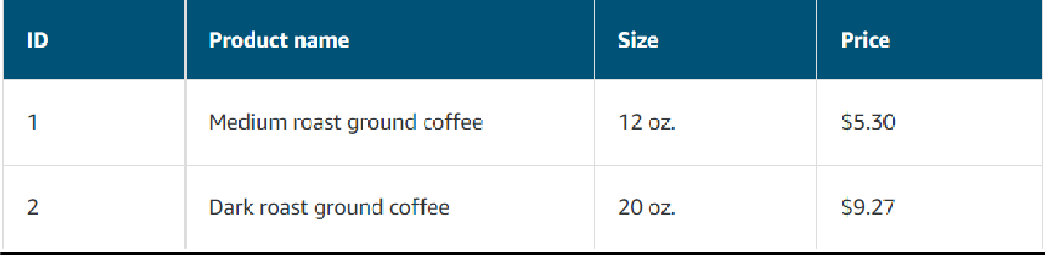Example of data in a relational database:

**Amazon RDS** is a managed service that automates tasks such as hardware provisioning, database setup, patching, and backups. With these capabilities, you can spend less time completing administrative tasks and more time using data to innovate your applications. You can integrate **Amazon RDS** with other services to fulfill your business and operational needs, such as using **AWS Lambda** to query your database from a serverless application.

**Amazon RDS** provides a number of different security options. Many **Amazon RDS** database engines offer encryption at rest (protecting data while it is stored) and encryption in transit (protecting data while it is being sent and received).

Amazon RDS database engines:

Amazon RDS is available on six database engines, which optimize for memory, performance, or input/output (I/O). Supported database engines include:

* + - Amazon Aurora
    - PostgreSQL
    - MySQL
    - MariaDB
    - Oracle Database
    - Microsoft SQL Server
  1. **AMAZON NONRELATIONAL DATABASES**

In a **nonrelational database**, you create tables. A table is a place where you can store and query data.

Nonrelational databases are sometimes referred to as “NoSQL databases” because they use structures other than rows and columns to organize data. One type of structural approach for nonrelational databases is key-value pairs. With key-value pairs, data is organized into items (keys), and items have attributes (values). You can think of attributes as being different features of your data.

In a key-value database, you can add or remove attributes from items in the table at any time. Additionally, not every item in the table has to have the same attributes.

Example of data in a nonrelational database:

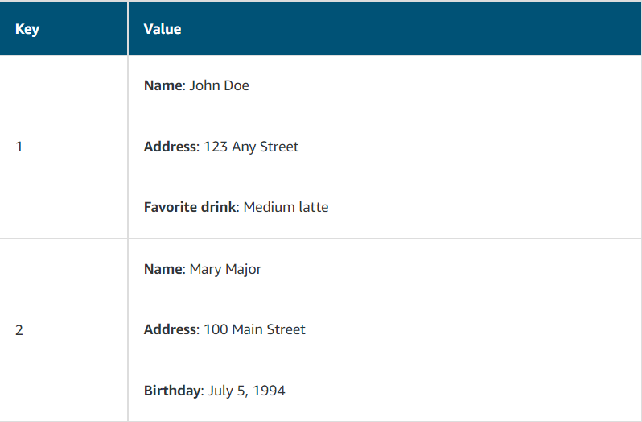

* 1. **AMAZON DYNAMODB**

[*Amazon DynamoDB*](https://aws.amazon.com/dynamodb/) is a key-value database service. It delivers single-digit millisecond performance at any scale.

Features of DynamoDB:

### Serverless:

DynamoDB is serverless, which means that you do not have to provision, patch, or manage servers.

You also do not have to install, maintain, or operate software.

### Automatic scaling:

As the size of your database shrinks or grows, DynamoDB automatically scales to adjust for changes in capacity while maintaining consistent performance.

This makes it a suitable choice for use cases that require high performance while scaling.

* 1. **AMAZON REDSHIFT**

[Amazon Redshift](https://aws.amazon.com/redshift) is a data warehousing service that you can use for big data analytics. It offers the ability to collect data from many sources and helps you to understand relationships and trends across your data.

* 1. **AWS DATABASE MIGRATION SERVICE (AWS DMS)**

[AWS Database Migration Service (AWS DMS)](https://aws.amazon.com/dms/) enables you to migrate relational databases, nonrelational databases, and other types of data stores.

With **AWS DMS**, you move data between a source database and a target database. [The source and target databases](https://aws.amazon.com/dms/resources) can be of the same type or different types. During the migration, your source database remains operational, reducing downtime for any applications that rely on the database.

For example, suppose that you have a MySQL database that is stored on premises in an **Amazon EC2** instance or in **Amazon RDS**. Consider the MySQL database to be your source database. Using **AWS DMS**, you could migrate your data to a target database, such as an **Amazon Aurora** database.

* 1. **ADDITIONAL DATABASE SERVICES**

### Amazon DocumentDB:

[*Amazon DocumentDB*](https://aws.amazon.com/documentdb) **i**s a document database service that supports MongoDB workloads. (MongoDB is a document database program.)

### Amazon Neptune:

[*Amazon Neptune*](https://aws.amazon.com/neptune) is a graph database service.

You can use Amazon Neptune to build and run applications that work with highly connected datasets, such as recommendation engines, fraud detection, and knowledge graphs.

### Amazon Quantum Ledger Database (Amazon QLDB):

[*Amazon Quantum Ledger Database (Amazon QLDB)*](https://aws.amazon.com/qldb) is a ledger database service. You can use Amazon QLDB to review a complete history of all the changes that have been made to your application data.

### Amazon Managed Blockchain:

[*Amazon Managed Blockchain*](https://aws.amazon.com/managed-blockchain) is a service that you can use to create and manage blockchain networks with open-source frameworks.

Blockchain is a distributed ledger system that lets multiple parties run transactions and share data without a central authority.

### Amazon DynamoDB Accelerator:

[*Amazon DynamoDB Accelerator (DAX)*](https://aws.amazon.com/dynamodb/dax/) is an in-memory cache for DynamoDB. It helps improve response times from single-digit milliseconds to microseconds.

* 1. **PRACTICAL EXPLANATION OF S3 BUCKETS**
  2. **CREATION OF A BUCKET:**

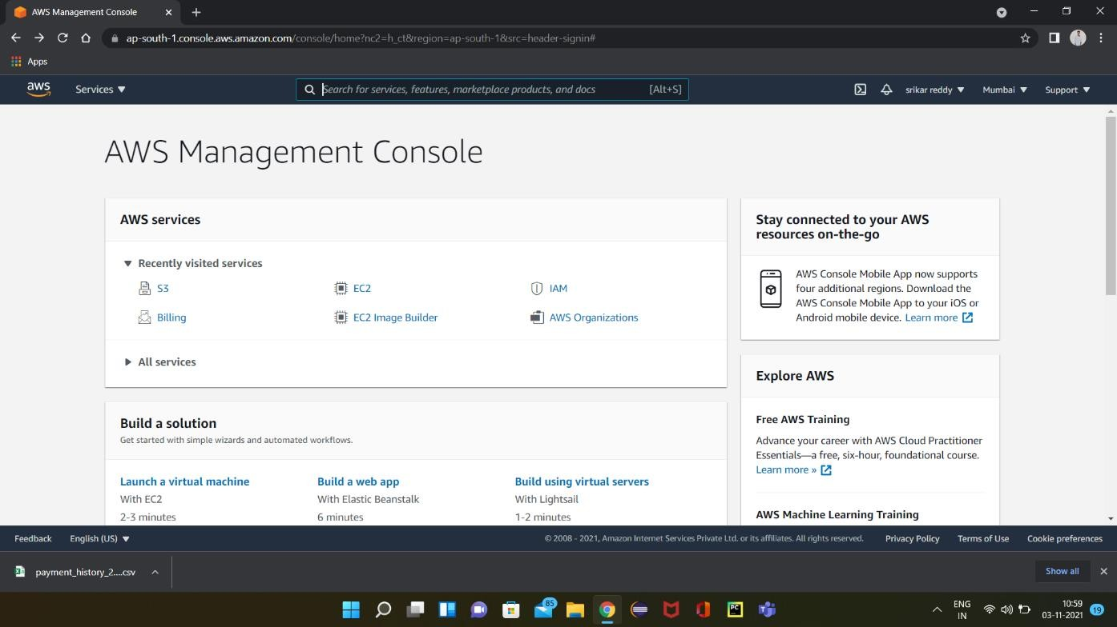

Step 1: Select S3 from the dashboard or search it in the search bar in AWS management console.

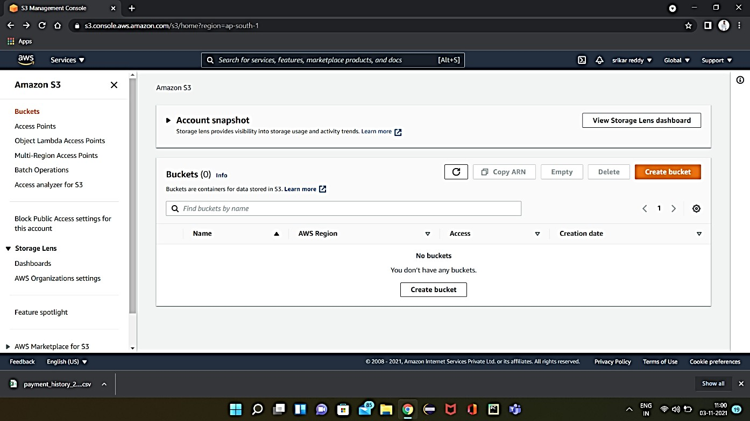

Step 2: In Amazon S3 bucket can be created by clicking on the “Create bucket” option.

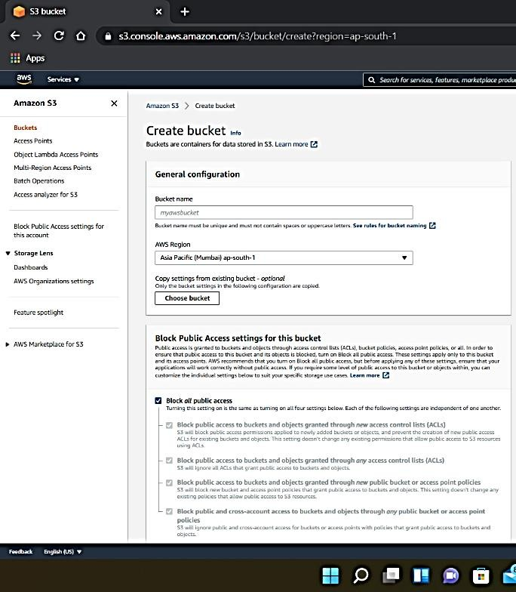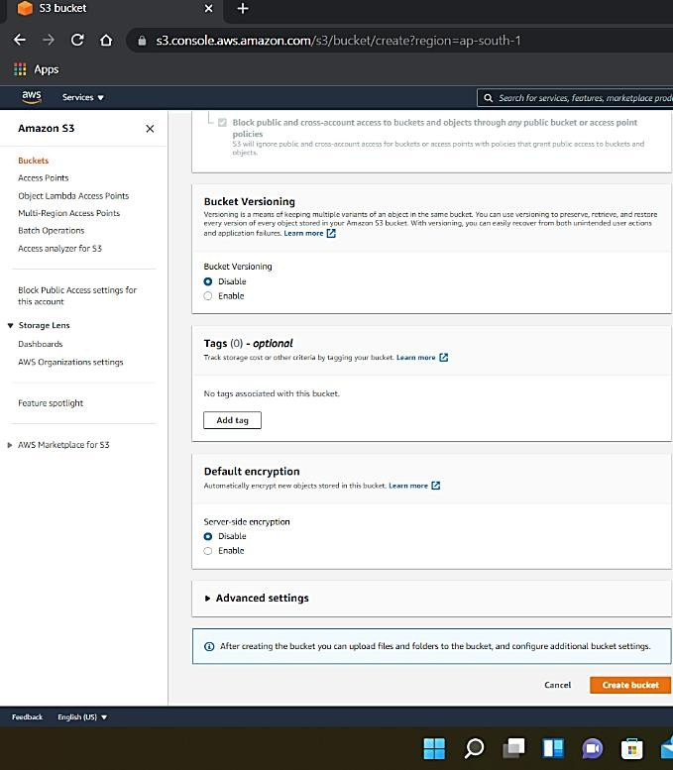

Step 3: Give a globally unique name for the bucket.

* + - Select a region which is nearby for accessing the bucket.
    - By default, the bucket is restricted from public access, permission can be changed if needed.
    - Other permissions like encryption, bucket versioning and tags are taken in default, they can be changed if necessary.
    - Then click on “Create bucket”.

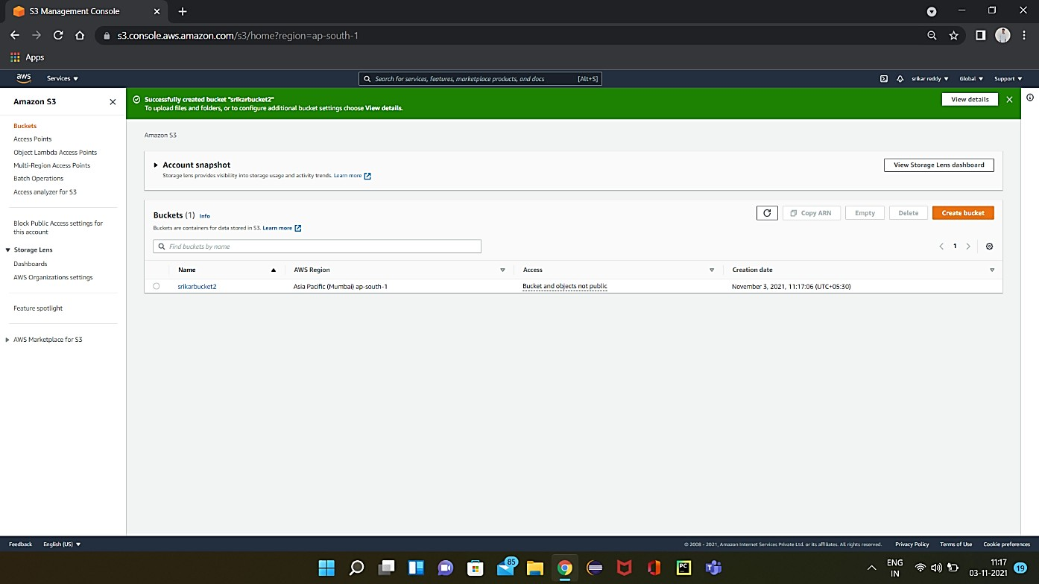

Step 4: Finally S3 bucket is created with the name given by the user.

* 1. **ACCESSING A BUCKET:**

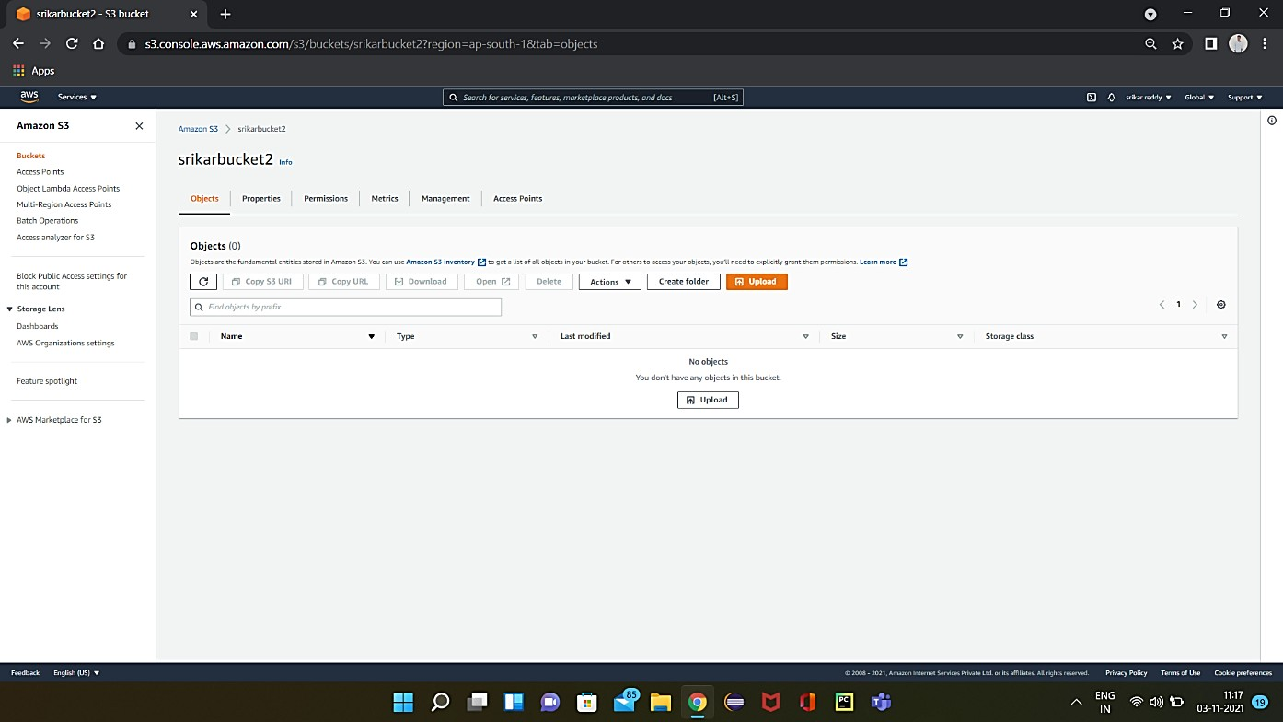

Step 1: To upload files in S3 bucket, click on “upload” option.

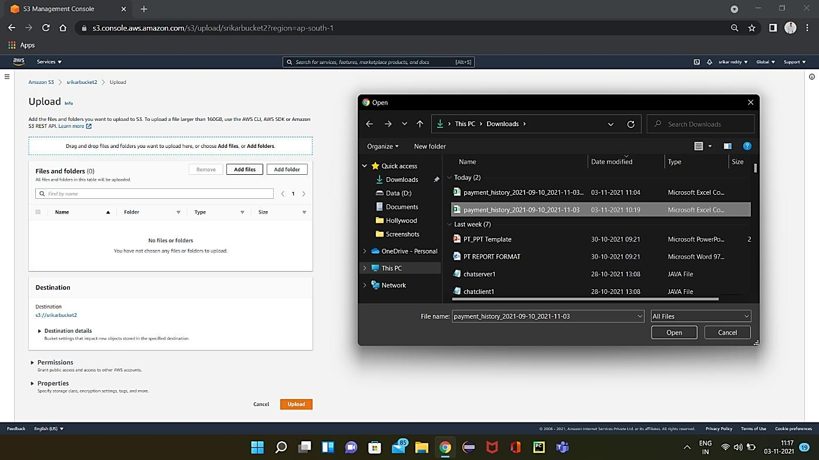

Step 2: Click on “Add files” and select the file to be added.

* + - Check the permissions and properties of the added file and click on “upload”.

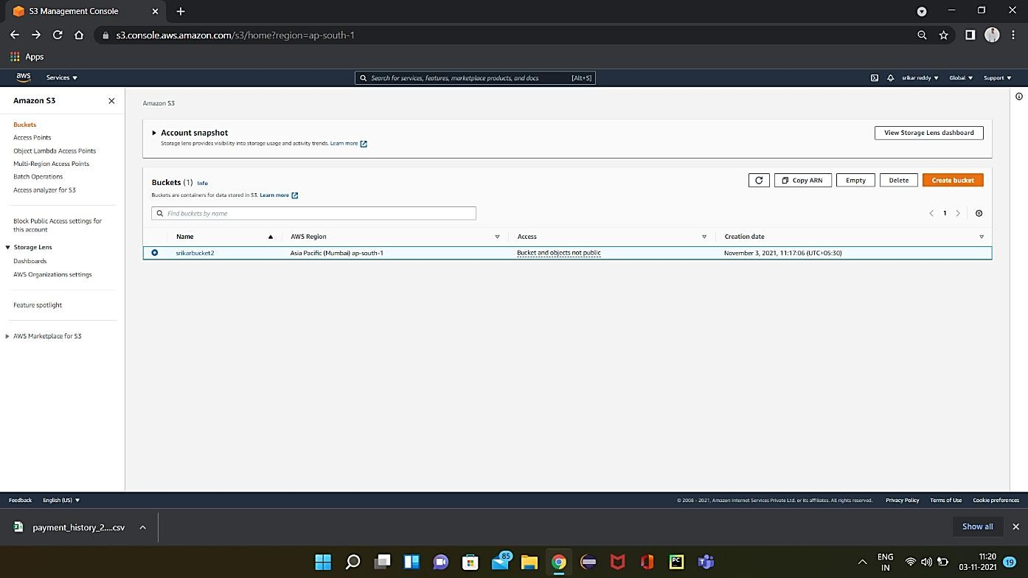

Bucket is created with the given name and in the selected region.

* 1. **DELETING A BUCKET:**

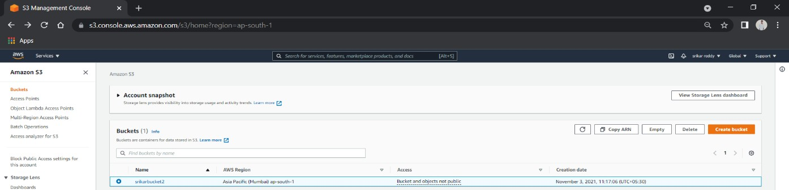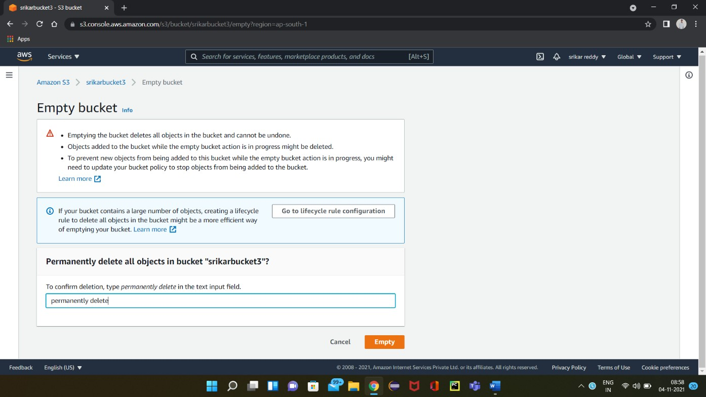

Step 1: To delete a bucket select the bucket to be deleted and select the “Empty” option Located on the right top of the page.

* + - To empty the bucket, fill the required input field and then select “Empty”.
    - All the objects in the bucket are removed and the bucket got empty.

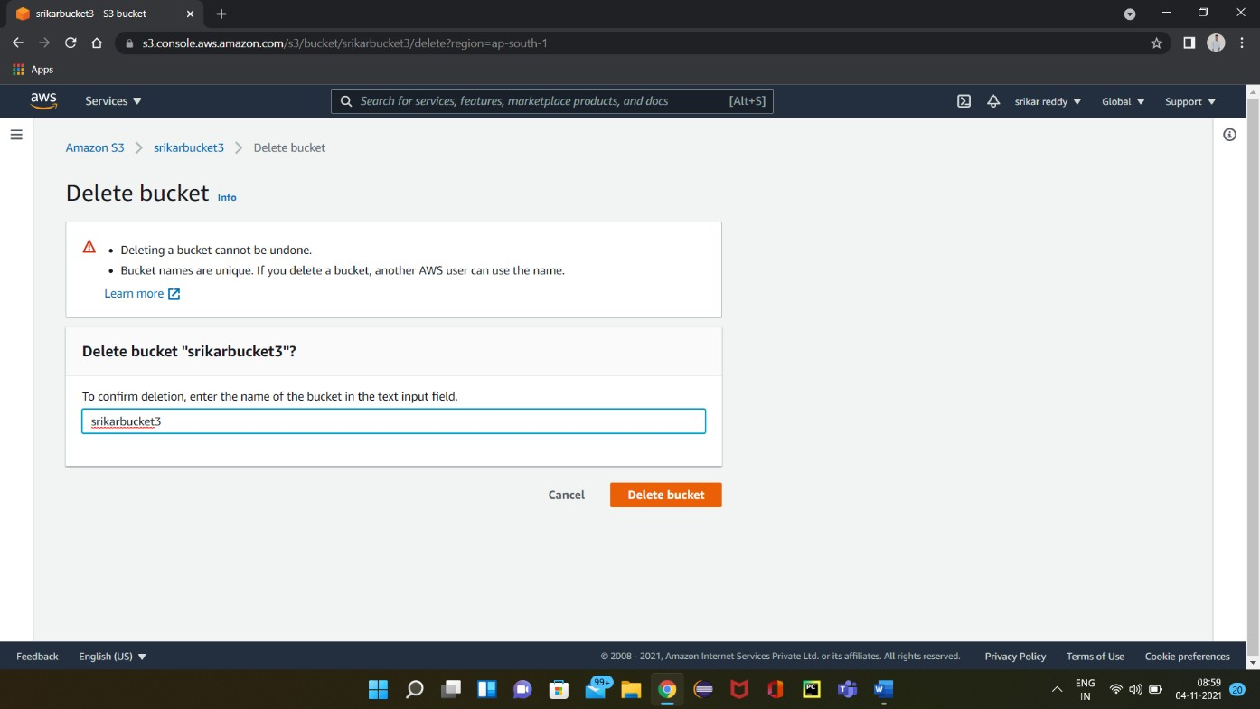

Step 2: After emptying the bucket go to the delete menu and enter the bucket name and select the option “Delete bucket”. The bucket got deleted.

(Note: A bucket can not be deleted directly without emptying it.)

* 1. **PRACTICAL EXPLANATION OF AMAZON EBS**

## CREATION OF EBS SNAPSHOTS:

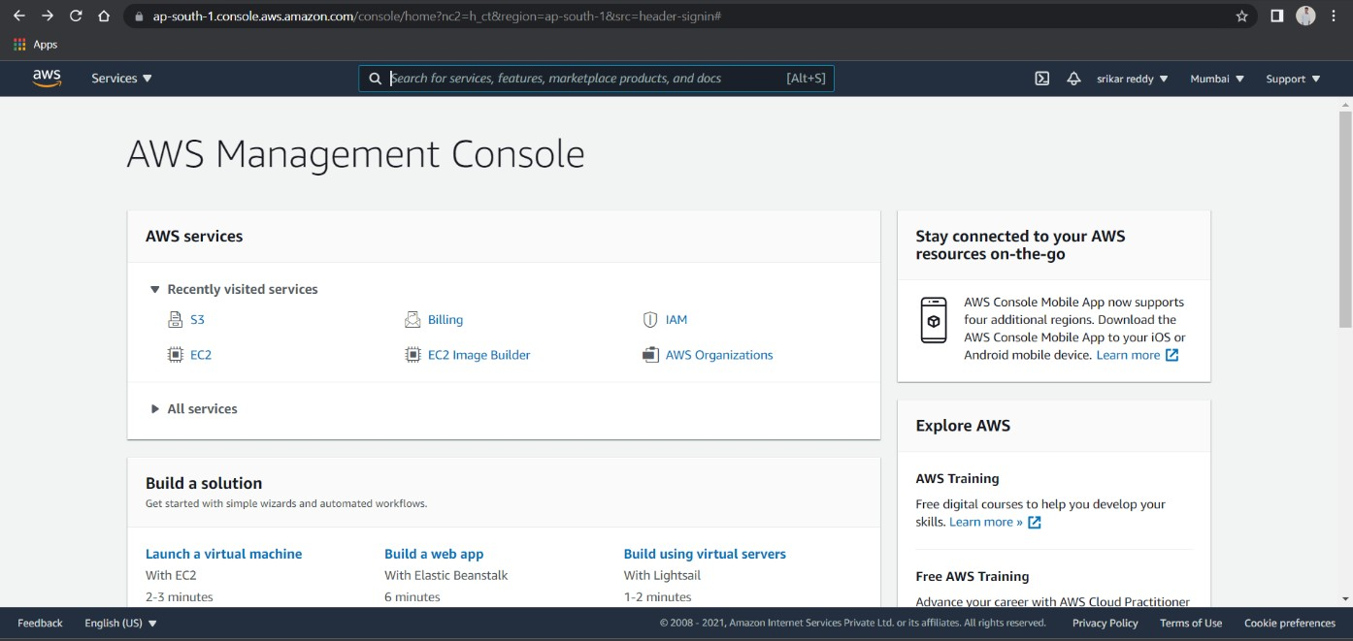

Step 1: For creating EBS Snapshot, go to EC2 by selecting it from management console.

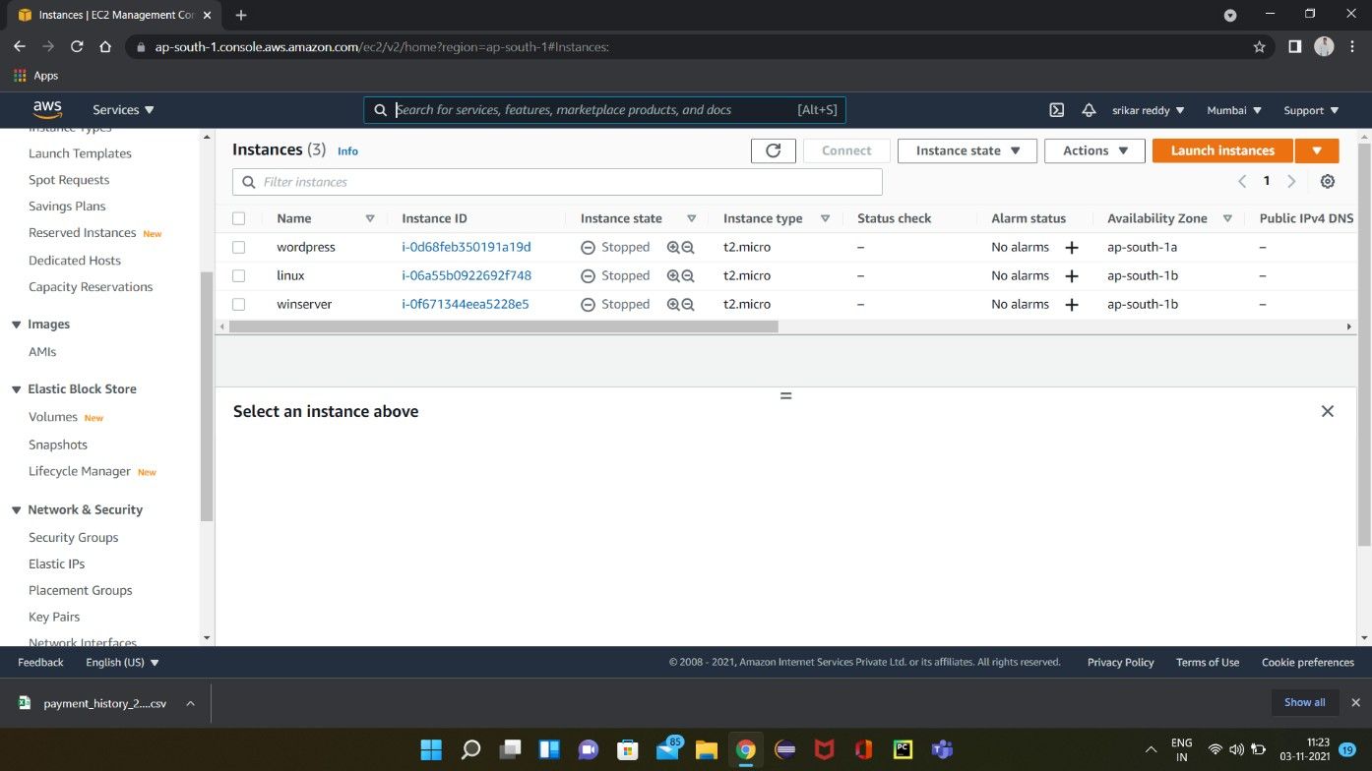

Step 2: After entering into EC2 dashboard, we can find Elastic Block Store on the left side and select snapshots.

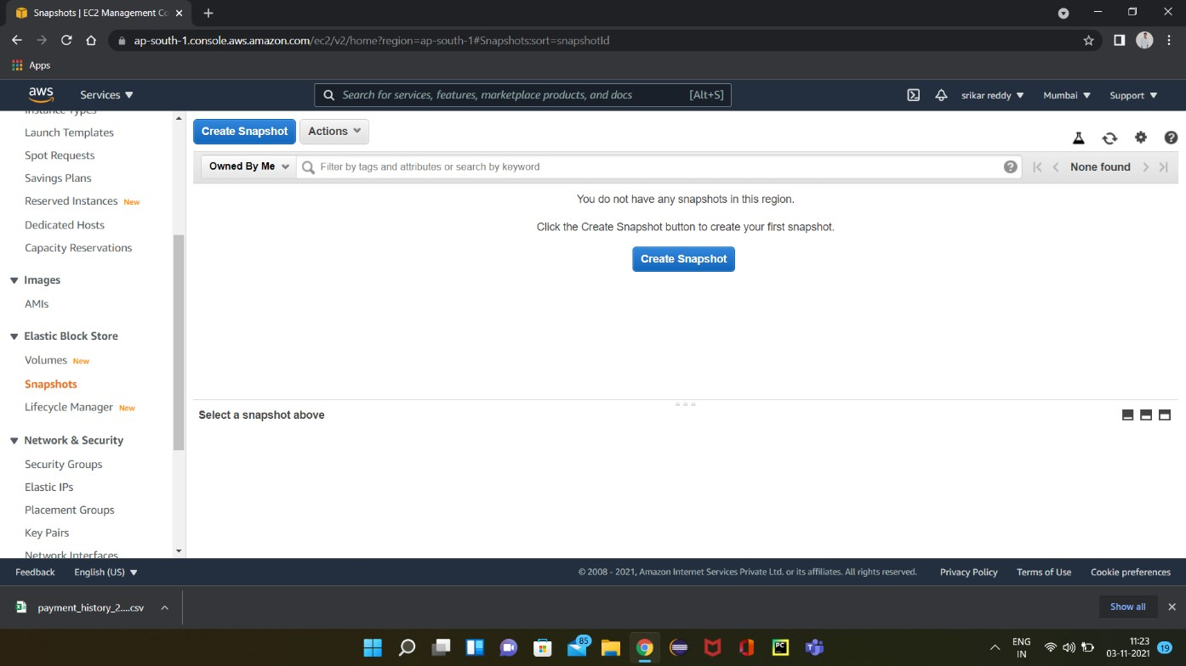

Step 3: Select “Create snapshot” to create a new snapshot.

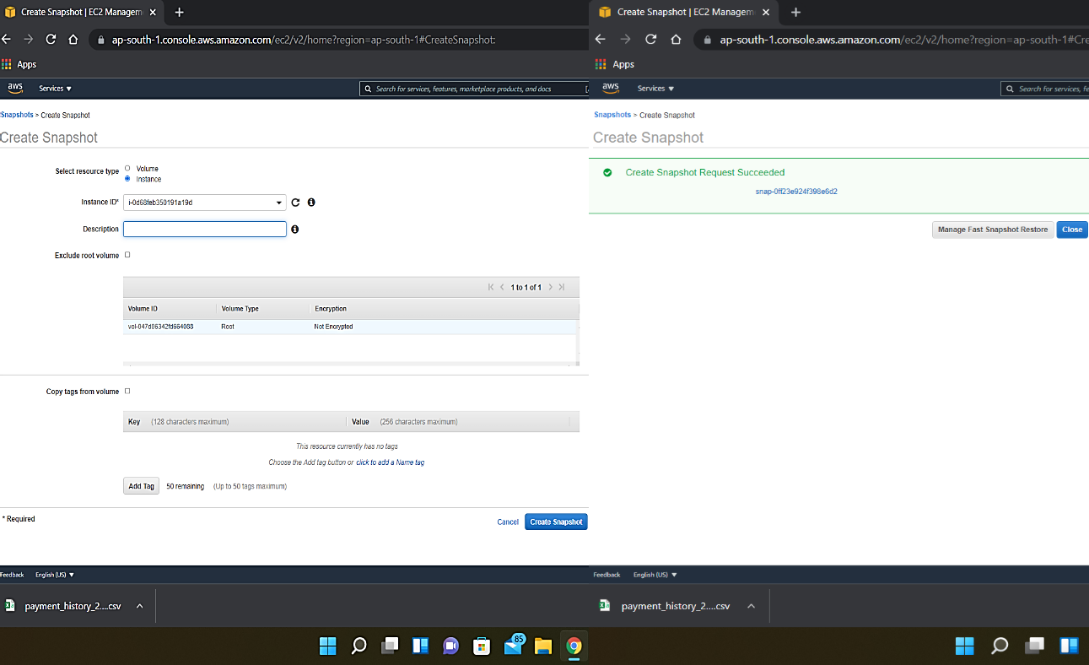

Step 4: Select the required volume or instance.

* + - Fill the blanks if necessary or leave them default and click on “Create Snapshot”.
    - Snapshot is created.

## DELETION OF SNAPSHOTS:

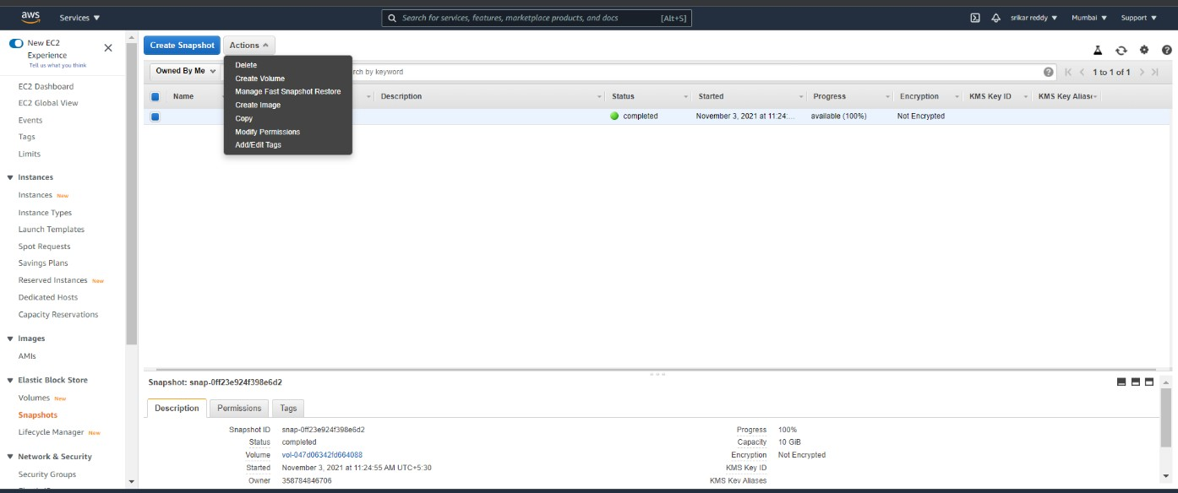

Step 1: For deleting a particular snapshot, select the snapshot.

* + - Click on “Actions” and select “Delete” option and the snapshot gets deleted.

# CONCLUSION

Cloud storage is an emerging technology and has a great changing impact on the way businesses and organizations manage their information and data. Cloud storage provides massive scalability, high performance, data resiliency, and 99.999% readability. Cloud storage is a critical component of cloud computing because it holds the information used by applications. Big data analytics, data warehouses, Internet of Things, databases, and backup and archive applications all rely on some form of data storage architecture.

Cloud storage is typically more reliable, scalable, and secure than traditional on premises storage systems. AWS offers a complete range of cloud storage services to support both application and archival compliance requirements. This whitepaper provides guidance for understanding the different storage services and features available in the AWS Cloud. Usage patterns, performance, durability and availability, scalability and elasticity, security, interface, and cost models are outlined and described for these cloud storage services. While this gives you a better understanding of the features and characteristics if these cloud services, it is crucial for you to understand your workloads and requirements then decide which storage service is best suited for your needs.

AWS offers a complete range of cloud storage services to support both application and archival compliance requirements. Select from object file, and block storage services as well as cloud data migration options to start designing the foundation of your cloud IT environment.

# REFERENCES

1. Mohd Tajammul, Iftikhar Aslam Tayubi, Rafat Praveen, ”Cloud Storage in Context of Amazon Web Services”, Volume 10, Issue 01-january-2021, page no:442-446.

<https://www.ijert.org/cloud-storage-in-context-of-amazon-web-services>

1. AWS Skill builder:

[https://explore.skillbuilder.aws/learn/course/6233/play/19879/core-aws-](https://explore.skillbuilder.aws/learn/course/6233/play/19879/core-aws-%20%20%20%20%20%20%20%20%20%20%20%20%20%20%20storage-services%3Blp%3D93) [storage-services;lp=93](https://explore.skillbuilder.aws/learn/course/6233/play/19879/core-aws-%20%20%20%20%20%20%20%20%20%20%20%20%20%20%20storage-services%3Blp%3D93)

1. Star Cloud Computing-Star Certification [https://elearning.starcertification.org/pluginfile.php/34086/mod_resource](https://elearning.starcertification.org/pluginfile.php/34086/mod_resource/content/1/Cloud%20Computing%20for%20LMS/Index.html%23/reader/chapter/54?vi=0)

[/content/1/Cloud%20Computing%20for%20LMS/Index.html#/reader/cha](https://elearning.starcertification.org/pluginfile.php/34086/mod_resource/content/1/Cloud%20Computing%20for%20LMS/Index.html%23/reader/chapter/54?vi=0) [pter/54?vi=0](https://elearning.starcertification.org/pluginfile.php/34086/mod_resource/content/1/Cloud%20Computing%20for%20LMS/Index.html%23/reader/chapter/54?vi=0)